FAIRVIEW CHURCH OF CHRIST
Community Intelligence Report
5-Mile Study Area · 2026-10-09
Report Date: 2026-10-09 · Church Address: 1000 Old Fort Parkway, Murfreesboro, TN 37129
Prepared for the elders, ministers and deacons of Fairview Church of Christ. Deliberative material — not for republication.
Generated 2026-10-09 09:16 CDT. This report is assembled automatically from public data sources and published research. Verify any fact before acting on it or repeating it publicly. Corrections: kairosnews2026@gmail.com

How the study area was drawn, what the tier labels [T1]–[T4] mean, and where each figure comes from are set out under SCOPE, METHOD, AND HOW TO READ THIS REPORT at the back of this report.

EXECUTIVE SUMMARY

HOW TO READ THIS SUMMARY
- Profiles: twelve fixed descriptions of where a person stands in relation to the gospel, not of what kind of person he is. Each keeps its number in every report and has a page of its own at kairosintelligence.org/audience-profiles. Those on this page:
- Profile 6, the Cultural Christian: Believers who have never obeyed the gospel
- Profile 4, the Casually Dechurched: Adults who stopped attending for entirely ordinary reasons
- Profile 9, the Bereaved and the Aging: Adults 65 and older facing loss and mortality
- Profile 10, the Newcomer: Immigrants, refugees, international students, and the second generation
- Profile 12, the Young Family Under Pressure: Married couples with school-age children, afraid for them
- Profile 11, the Self-Sufficient: Comfortable, successful adults with no felt need
- Profile 1, the Untethered: Young adults with no religious frame of reference at all
- Tiers: how far to lean on a figure.
- T1: counted — a published statistic.
- T2: estimated — a state or national rate applied here.
- T3: reported by a local source.
- T4: the report’s own estimate, a starting point rather than a finding.
- Carrier route: the few hundred homes one letter carrier serves, and the unit a mailing is bought by. Route numbers match the map in Section III.
- Under 200% of poverty: household income below twice the federal poverty threshold — households who are struggling though often not officially poor.
- ACS: the Census Bureau’s American Community Survey, the source of most figures here.

KEY FINDINGS
- Profile 6, the Cultural Christian: about 67,000–77,000 adults [T2]
- Profile 4, the Casually Dechurched: about 18,000–31,000 adults [T2/T4]
- Profile 9, the Bereaved and the Aging: about 11,000–16,000 adults [T2]
- Identify as Christian but do not attend weekly: 23,813–41,956 [T2]
- Share of churched adults in traditions not practicing immersion for remission: about 94% [T4]
- Context: 161,445 [T1] in Murfreesboro, 145,510 [T2] in the study area; median household income $80,108 city [T1]; ≈ $74,800 study area [T2]; foreign-born 9.0% study area [T2]; 8.8% Murfreesboro city [T1]

Where the Figures Come From
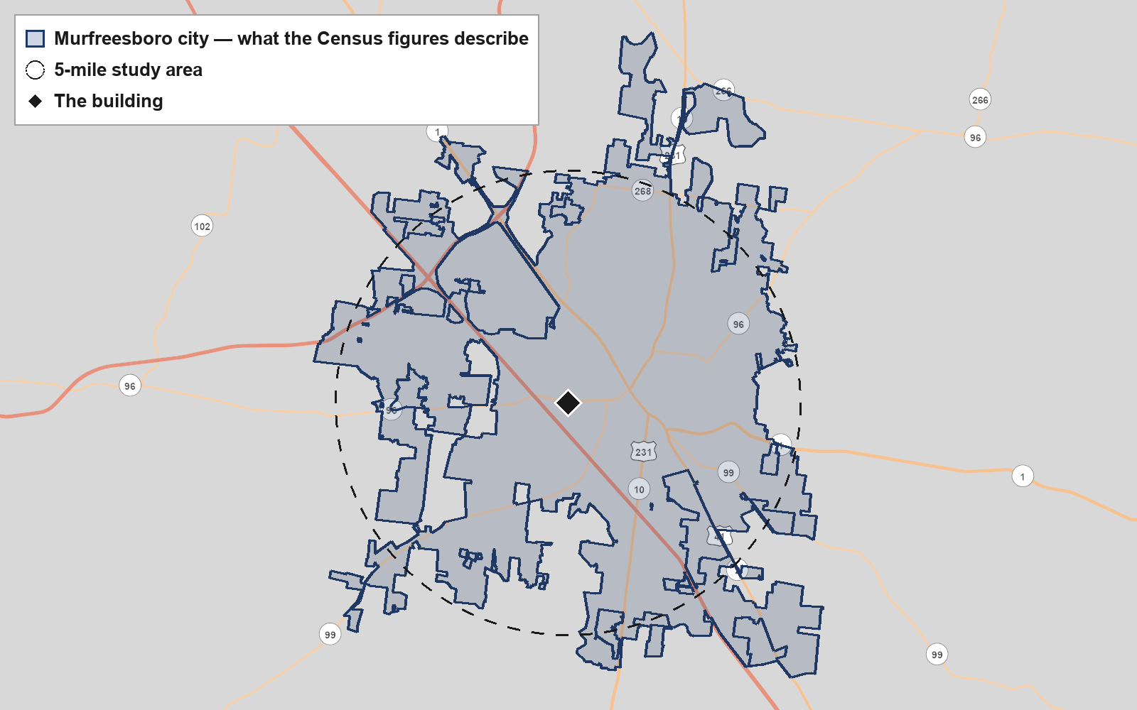
The Census figures in this report describe Murfreesboro city, outlined and shaded. The building is marked, and the dashed circle is the 5-mile study area this report describes. Where the outline and the circle differ, the Census figures and the study area are not the same place, and the figures should be read as describing Murfreesboro city. Base map: U.S. Census Bureau, TIGERweb.

The Field
The largest condition in this 5-mile field of 145,510 people [T2] is Profile 6, the Cultural Christian: an estimated 66,903 to 77,109 adults [T2] who identify as Christians but were never immersed for the forgiveness of sins. Next is Profile 4, the Casually Dechurched (17,860–31,467 [T2]). Profiles 9, 10, 12 and 11 (the Bereaved and the Aging; the Newcomer; the Young Family Under Pressure; the Self-Sufficient) then run nearly level. The field is young (median age 31.6 [T1]), half renters (50.7% own [T2]) and growing fast (+18.4% [T1]), and Churches of Christ hold 4% of Tennessee adults [T1].

OUR RECOMMENDATION
The largest condition is Profile 6, the Cultural Christian, and Fairview should start there, through members' friendships, a January class on what baptism does and a findable web page, with widowed neighbors as a second effort.

Why
1. Profile 6, the Cultural Christian, is more than twice the size of any other condition in the field.
Evidence: Profile 6, the Cultural Christian: 66,903–77,109 [T2]; next largest, Profile 4, the Casually Dechurched: 17,860–31,467 [T2] (Section I)

2. In this field, a churchgoer has usually not obeyed the gospel, so teaching about baptism matters more than a general invitation.
Evidence: Tennessee is 72% Christian and 4% Churches of Christ [T1]; World Outreach Church draws about 15,000 a week [T3] (Section IX)

3. The streets beside the building turn over too fast for 65 volunteers to hold, while teaching uses what the congregation already has.
Evidence: Routes 37129-C006, C013, C021: 77–84% renting, 40–42% aged 18–34 [T2]; 65 active volunteers, no vehicle (Section III)

WHAT WE ARE LEAST SURE OF
The Profile 6, the Cultural Christian, size applies state and metro Pew identification (±4.4 pts) to a young university city. If Murfreesboro is less Christian than the state, Profiles 1 and 4 (the Untethered; the Casually Dechurched) grow, and the class must start further back.

What to Do First
With 240 members, 185 attending and 65 active volunteers, Fairview can carry two efforts: one teaching effort and one service effort grown from its assisted-living visits.

START HERE
Profile 6, the Cultural Christian, through members' networks and a January class. It is the largest field (66,903–77,109 [T2]) and needs teachers, not a vehicle or a language.

Fix Before Inviting Anyone
- 8–10 members trained to teach the conversions in Acts
- A plain web page on baptism and a verified Google Business Profile
- A roster of member drivers, since there is no church vehicle
- The two Spanish-speaking members paired with any Spanish-speaking contact

Priorities, in Order
1. Train 8–10 members to lead a home study through the conversions in Acts before the January class.
Because: Profile 6, the Cultural Christian, is 66,903–77,109 adults [T2], and it needs teachers more than money or a vehicle. (Section I)
Six-month target: 8 teachers trained by December; 12 home studies begun by April

2. Claim the Google Business Profile and publish a plain page on what Fairview teaches about baptism.
Because: Profile 6, the Cultural Christian, is spread across the field, and someone asking whether baptism is necessary has to find an answer. (Section IX)
Six-month target: Page live and profile verified by October 31

3. Hold a four-week public class in January, 'What does baptism do?', reading every conversion in Acts.
Because: Tennessee is 72% Christian with 4% in Churches of Christ [T1]; most hearers believe the question is settled. (Section IX)
Six-month target: 15 guests who are not members; 5 continue into home studies

4. Move the assisted-living visit from quarterly to monthly and add a second residence from the access list.
Because: 16,743 residents are 65+ and 12,508 are widowed in the study area [T2]. (Section VII)
Six-month target: 6 monthly visits across 2 residences by April

5. Mail routes 37128-R019 and 37128-C034 offering a member's visit, a meal or a ride.
Because: Their profiles show 15% and 22% widowed [T2], the highest near the building. (Section III)
Six-month target: Every household that responds is helped; about 20 visited by April

Coming Up
Month | What to Do | Why Then
October | Claim the Google Business Profile, publish a baptism page, recruit 8–10 teachers, and set the January class dates. | Fall break Oct 5–9 in Murfreesboro City Schools and Rutherford County Schools has ended; early voting opens Oct 14 per the Murfreesboro Post
November | Mail routes 37128-R019 and C034 offering visits, meals and rides; deliver Thanksgiving meals; begin monthly residence visits. | Rutherford County Schools Thanksgiving break Nov 23–27; Murfreesboro Transit links the Cason Lane pilot route to the Transit Center
December | Hold a residence visit with singing; members invite friends to the January class; start social ads within 3 miles. | MTSU full term ends Dec 10; both school districts break Dec 21–Jan 1

WHAT SHOULD WAIT
Profile 10, the Newcomer, waits for more Spanish or Arabic speakers. The 37129-C029 benevolence mailing and the apartment corridor wait until the teachers and visitors are in place.

The rest of the report is the evidence for this summary: the efforts one by one, who is in the field (I–IV), what this congregation can carry (V), the year’s calendar, concerns and literature (VI–VIII), and the supporting figures (IX–XIII).

THE EFFORTS, ONE BY ONE

Each effort below gathers what this report says about it in one place. The monthly campaign portfolio plans these same efforts in detail — phases, budget and volunteers.

Effort 1 (start here) — What does baptism do?
Who | Adults across the 5-mile field who believe and attend somewhere, or used to, starting with members' own friends and family. (Profile 6, the Cultural Christian; Profile 4, the Casually Dechurched)
Why this effort | Profile 6, the Cultural Christian, is 66,903–77,109 adults [T2], more than twice any other condition.
How to reach them | Members' networks: Each member names three friends or relatives who believe but were not immersed for remission, and invites them in person. Reach: not measurable from this report. Search: A plain page on what baptism does, plus search ads on questions such as 'is baptism necessary'. Reach: not measurable from this report. Social media: Ads by distance and age only, e.g. 'What does the Bible say baptism does? A four-week class in January.'. Reach: 49,782 adults within 3 miles [T2], 3-mile row of POPULATION BY RADIUS.
When | October 2026, December 2026, January 2027, February 2027 — see the calendar in Section VI
What to offer | A four-week public class reading every conversion in Acts, and a home Bible study for anyone who asks.
Invitation | To the class, to Sunday worship, and to a home study. Contact with anyone under 18 goes through a parent.
What to bring | I Thought I Was Already Saved; You Can Come Back
Fix first | 8–10 members trained to teach the conversions in Acts; A plain web page on baptism and a verified Google Business Profile
How you will know | By early January: page and profile live, 8 teachers trained, and members holding at least 10 named invitations for the class.

Effort 2 — Widows and older neighbors
Who | Older and widowed neighbors on routes 37128-R019 and 37128-C034 and in nearby senior residences. (Profile 9, the Bereaved and the Aging)
Why this effort | 16,743 aged 65+ and 12,508 widowed in the study area [T2]; Fairview already visits assisted living quarterly.
How to reach them | Mail routes: One mailing offering a visit, a meal or a ride, with a phone number a member answers. Reach: 1,387 homes on the two routes per USPS EDDM; profiles [T2]. Local presence: Monthly visits at two residences, on the residences' schedule and terms. Reach: not measurable from this report. Members' networks: Members name widowed neighbors and friends who would welcome a visit or a meal. Reach: not measurable from this report.
Where | #3 37128-R019 (626 homes); #5 37128-C034 (761 homes); A: Harmony at Victory Station; B: AdamsPlace; C: American House Murfreesboro
When | November 2026, December 2026, January 2027, February 2027, March 2027 — see the calendar in Section VI
What to offer | Monthly visits with singing and Scripture for those who want it, meals, and rides to appointments in members' cars, given whether or not anyone comes on Sunday.
Invitation | To Sunday worship with a ride offered, and a home study for any who ask.
What to bring | Not Without Hope
Fix first | A roster of member drivers, since there is no church vehicle
How you will know | By January: three monthly visits held, every responding household helped, and at least 8 member drivers on the roster.

PART ONE — THE FIELD

I. THE SPIRITUAL FIELD — LOCAL SIZING

These are the twelve Gospel Audience Profiles, sized for this study area. Each is described in full, with the pamphlet written for it, at kairosintelligence.org/audience-profiles, under the same number and name it carries here. The numbers and definitions are the same for every congregation; the sizes and the order are local. Where this report speaks of a condition, it means one of these profiles.
A profile describes where a person stands in relation to the gospel, not what kind of person he is. A person may fit more than one, and no one the congregation meets will be only one of them.

Rank | Profile | Estimated Size | Confidence | Concentrated In
1 | Profile 6, the Cultural Christian — Believers who have never obeyed the gospel | about 67,000–77,000 | moderate · T2 | Field-wide, 37128 owner-occupied streets
2 | Profile 4, the Casually Dechurched — Adults who stopped attending for entirely ordinary reasons | about 18,000–31,000 | low · T2/T4 | Apartment corridor by the building, 37129-R071 streets
3 | Profile 9, the Bereaved and the Aging — Adults 65 and older facing loss and mortality | about 11,000–16,000 | moderate · T2 | 37128 owner-occupied streets, 37128-C034 rentals, Senior residences
4 | Profile 10, the Newcomer — Immigrants, refugees, international students, and the second generation | about 13,000–18,000 | moderate · T2 | MTSU area, Field-wide
5 | Profile 12, the Young Family Under Pressure — Married couples with school-age children, afraid for them | about 12,000–17,000 | low · T2 | 37128 owner-occupied streets, 37129-C029/R013 streets
6 | Profile 11, the Self-Sufficient — Comfortable, successful adults with no felt need | about 9,700–19,000 | low · T2/T4 | 37128 owner-occupied streets
7 | Profile 5, the Church-Hurt — Adults who left because of what was done to them | about 6,000–10,000 | low · T2/T4 | Field-wide
8 | Profile 1, the Untethered — Young adults with no religious frame of reference at all | about 4,200–8,400 | low · T2/T4 | Apartment corridor by the building, MTSU area
9 | Profile 2, the Young Man Looking for Something Solid — Men roughly 18–34 who are actively searching | Cannot be estimated | low · T2 | Apartment corridor by the building, MTSU area
10 | Profile 3, the Young Woman Walking Out — Women roughly 18–34 leaving faith, for reasons they can state | Cannot be estimated | low · T2 | Apartment corridor by the building, MTSU area
11 | Profile 7, the Man in the Middle — Working-age men carrying shame, isolation, and often dependence | Cannot be estimated | low · T2 | Field-wide
12 | Profile 8, the Woman Carrying the Household — Single mothers and caregivers with no margin | Cannot be estimated | low · T2 | 37129-C029/R013 streets

Each profile keeps its number, 1 to 12, in every report, every campaign portfolio and on kairosintelligence.org; wherever this report names a profile it uses that number. Rank is this field’s own order, largest first.

LOCAL VS. NATIONAL ORDERING
Profile 6, the Cultural Christian, leads far more than nationally, because of Tennessee's density. Profiles 9, 10, 12 and 11 (the Bereaved and the Aging; the Newcomer; the Young Family Under Pressure; the Self-Sufficient) are within about 1,700 at midpoint, so they are effectively tied.

Profiles That Could Not Be Sized
- Profile 2, the Young Man Looking for Something Solid — requires: A published rate of young men returning to religious practice
- Profile 3, the Young Woman Walking Out — requires: A published rate of religious disaffiliation among women 18–34
- Profile 7, the Man in the Middle — requires: A local or national rate of social isolation among men 35–64
- Profile 8, the Woman Carrying the Household — requires: Study-area single-parent count (B11003 by block group); Count of family caregivers

A NOTE ON USING THIS SECTION
A profile is a tool for preparing, not a verdict for pronouncing. Use these to anticipate, then listen to the person in front of you and let him correct you.

II. NEIGHBORHOOD MINISTRY PRIORITY MAP

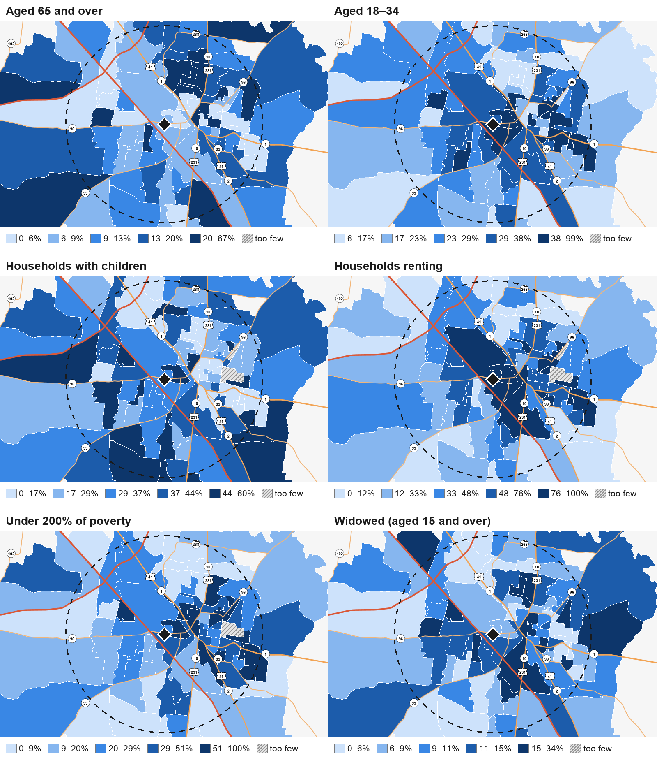
Each panel shades the Census block groups within about 5 miles in five bands, from the lowest value in this study area to the highest; the legend under each gives the ranges. Block-group estimates rest on small samples, so read the shading as where people are rather than as exact figures. Hatched areas have fewer than 100 people or households for that measure, too few to shade. Block groups centered inside the ring hold about 145,510 people [T2]. Source: ACS 2024 5-year block groups; base map: U.S. Census Bureau, TIGERweb.

The map covers the whole study area. The areas listed below are the ones near the building, where a congregation can realistically work. Distance from the building is the constraint nothing else overcomes. The bands below run outward from the church: the narrowest at the top is what the congregation can reach on foot, and each band beneath it costs more to serve than the one above.

◉ THE BUILDING

Within 1 mile — walking distance 5 areas
Apartment corridor by the building (37129-C006, C013, C021, R024) 0.1–1.0 mi · Profile 1, the Untethered; Profile 4, the Casually Dechurched; Profile 6, the Cultural Christian
77–84% renters, 38–42% aged 18–34 [T2]; turns over quickly. Best reached later through search and a welcome card.
37128 owner-occupied streets (R019, R040, R046, R031) 0.5–1.1 mi · Profile 6, the Cultural Christian; Profile 12, the Young Family Under Pressure; Profile 9, the Bereaved and the Aging; Profile 11, the Self-Sufficient
Mostly owners with children, $91,000–$108,000 medians [T2]. R019 carries 18% over 65. Stable homes for class invitations.
37129-R071 streets 0.5 mi · Profile 6, the Cultural Christian; Profile 4, the Casually Dechurched
Median age 35.2, 65% renting [T2]; settled enough for a class invitation.
37128-C034 rentals 0.7 mi · Profile 9, the Bereaved and the Aging; Profile 8, the Woman Carrying the Household
88% renting and 22% widowed (15+) [T2]: older widowed renters, a fit for visits and meals.
37129-C029/R013 streets 1.0–1.1 mi · Profile 8, the Woman Carrying the Household; Profile 12, the Young Family Under Pressure
Young families with children (40–42%) and median incomes of $52,000–$81,000 [T2]; practical help comes first.

Distance not recorded 2 areas
MTSU area not available · Profile 1, the Untethered; Profile 10, the Newcomer
About 20,867 students [T3]. Contact under 18 only through parents; international student count not retrieved.
Unincorporated Rutherford County within 5 miles not available · Profile 6, the Cultural Christian; Profile 12, the Young Family Under Pressure
23.7% of study-area residents [T2]; served by Rutherford County Schools; reached through members who live there.

Profiles are named by their number, as in Section I; the appendix defines each one.

III. ACCESS & TRANSPORTATION

Physical access to the building and to the baptistery, and the ability to get here at all, are binding constraints for several of the profiles above. These are solved before an invitation is extended, not after.

Access
Public transit | limited
Notes | No church vehicle, so rides depend on members' cars. Murfreesboro Transit runs eight routes, still below pre-pandemic ridership [T3]. Sunday service not confirmed. Baptistery is step-free.

Senior Residences in the Study Area
Map | Facility | Distance | Carrier Route
A | Harmony at Victory Station | 2.7 mi | beyond the mapped routes
B | AdamsPlace | 3.1 mi | beyond the mapped routes
C | American House Murfreesboro | 4.5 mi | beyond the mapped routes
D | Stones River Manor | 3.7 mi | beyond the mapped routes
E | Park View Meadows | 2.9 mi | beyond the mapped routes
F | The Villages of Murfreesboro | 1.6 mi | #10 37129-R024
G | Creekside at Three Rivers | 2.6 mi | beyond the mapped routes
H | NHC Murfreesboro | 2.4 mi | beyond the mapped routes

Distances are straight-line from the building. Letters mark each residence on the route map below; a residence the address lookup could not place keeps the distance the research gave.

Mail Routes Near the Building
What to mail where, route by route:
- #1 37129-C006 — Young renters beside the building, Profiles 1 and 4 (the Untethered; the Casually Dechurched); a welcome card with service times and the baptism web page suits them, deferred until a second cycle.
- #2 37129-R071 — Mixed renters and owners, median age 35.2: Profiles 6 and 4 (the Cultural Christian; the Casually Dechurched); a postcard inviting to the January class on what baptism does would suit.
- #3 37128-R019 — Chosen for age: 18% over 65 and 15% widowed, mostly owners (Profile 9, the Bereaved and the Aging). Mail offers a member's visit, a meal or a ride, with a Sunday invitation alongside.
- #4 37128-R040 — Larger households (2.9), 40% with children, median income about $91,000: Profiles 12 and 6 (the Young Family Under Pressure; the Cultural Christian); a postcard inviting parents to the January class.
- #5 37128-C034 — Chosen for widowhood: 22% widowed, mostly renting (Profile 9, the Bereaved and the Aging). Mail offers a visit, a meal or a ride from a member, with an invitation alongside.
- #6 37129-C013 — Young renters, 40% aged 18–34: Profiles 1 and 4 (the Untethered; the Casually Dechurched); a simple welcome card fits, deferred while capacity goes to Profiles 6 and 9 (the Cultural Christian; the Bereaved and the Aging).
- #7 37129-C021 — Youngest route (median age 29.7), mostly renting: Profiles 1 and 4 (the Untethered; the Casually Dechurched); a welcome card fits later, not in this cycle.
- #8 37128-R046 — Mostly owners, 35% with children, median income about $94,000: Profiles 12, 6 and 11 (the Young Family Under Pressure; the Cultural Christian; the Self-Sufficient); a postcard inviting to the January class.
- #9 37129-R013 — Young families (median age 29.8, 40% with children): Profiles 12 and 8 (the Young Family Under Pressure; the Woman Carrying the Household); a card offering the Saturday benevolence closet with class times alongside.
- #10 37129-R024 — Largest renting route near the building, 38% aged 18–34: Profiles 1 and 4 (the Untethered; the Casually Dechurched); a welcome card fits later, not in this cycle.
- #11 37129-C029 — Chosen for hardship: 51% under 200% of poverty, 42% with children (Profile 8, the Woman Carrying the Household). Mail offers Saturday benevolence closet help, invitation alongside; deferred.
- #12 37128-R031 — Owners, median income about $95,000: Profiles 11, 12 and 6 (the Self-Sufficient; the Young Family Under Pressure; the Cultural Christian); a plain postcard inviting to the January class on what baptism does.

USPS carrier routes within about a mile and a half, nearest first. Every Door Direct Mail reaches every household on a route with no mailing list; a congregation chooses routes, not addresses. These routes are mailed through the Murfreesboro post office.

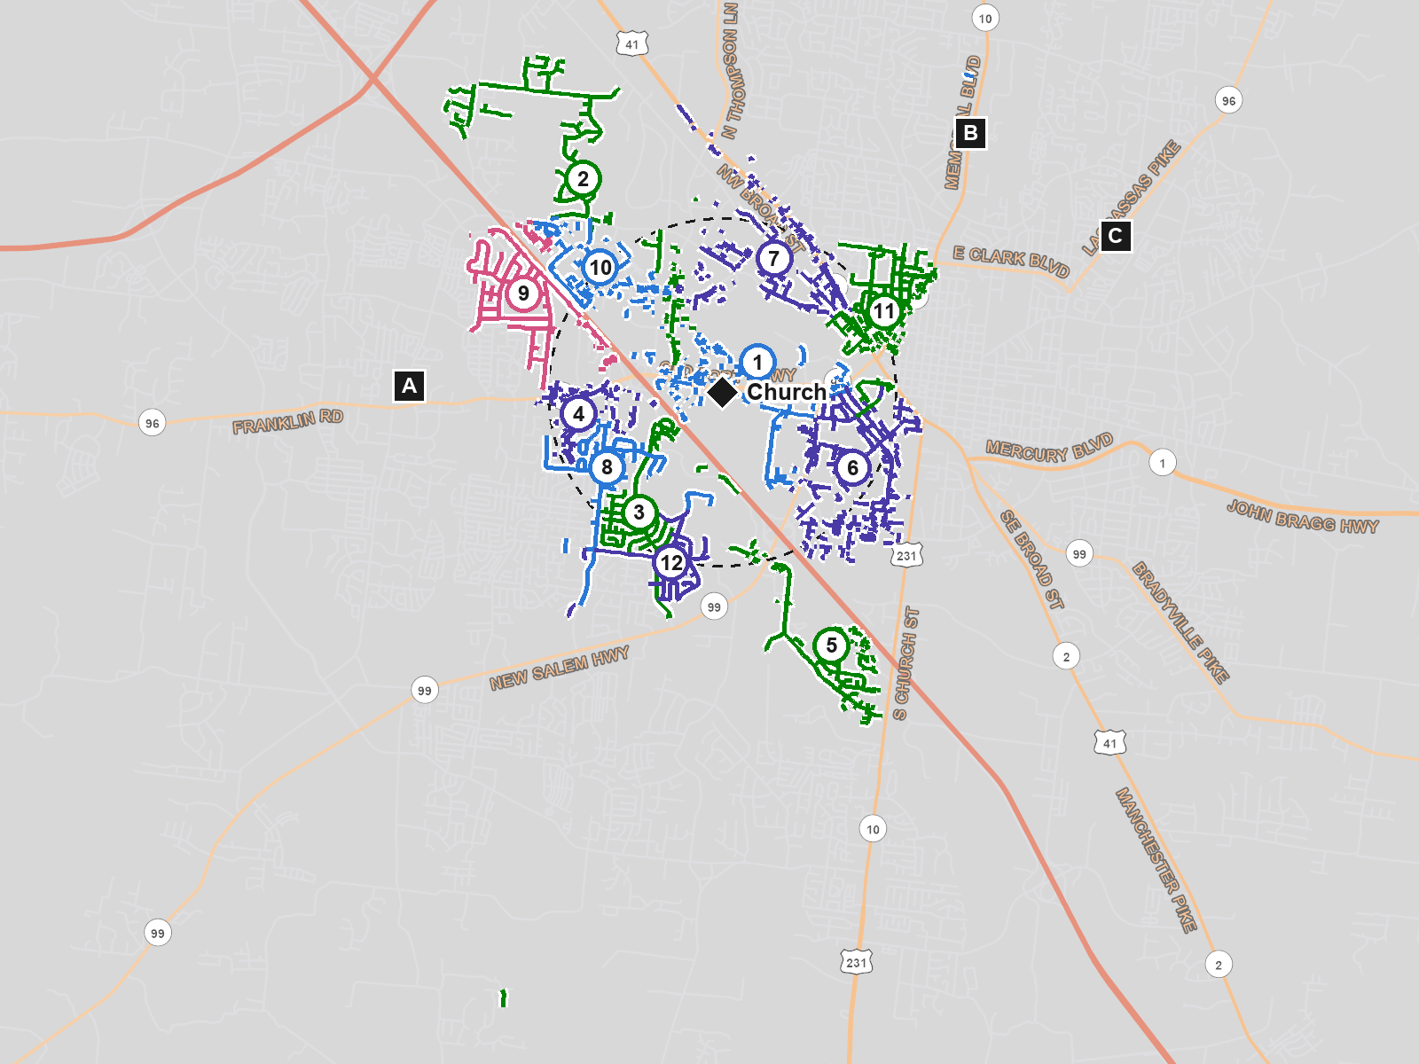
Each route is drawn along its streets and numbered to match the tables below; colors only keep neighboring routes apart. The dashed circle is 1.5 miles from the building. Lettered squares are the senior residences in the table above. Base map: U.S. Census Bureau, TIGERweb. Routes: USPS.

# | Route | Homes | Distance | Median Age | 65+ | 18–34 | Renting | With Children
1 | 37129-C006 | 713 | 0.1 mi | 30.2 | 7% | 42% | 83% | 32%
2 | 37129-R071 | 794 | 0.5 mi | 35.2 | 7% | 33% | 65% | 29%
3 | 37128-R019 | 626 | 0.5 mi | 36.7 | 18% | 26% | 15% | 34%
4 | 37128-R040 | 602 | 0.6 mi | 30.4 | 9% | 31% | 49% | 40%
5 | 37128-C034 | 761 | 0.7 mi | 32 | 6% | 36% | 88% | 39%
6 | 37129-C013 | 329 | 0.7 mi | 32.2 | 7% | 40% | 84% | 35%
7 | 37129-C021 | 209 | 0.7 mi | 29.7 | 7% | 42% | 77% | 28%
8 | 37128-R046 | 750 | 0.8 mi | 32.9 | 13% | 32% | 34% | 35%
9 | 37129-R013 | 804 | 1 mi | 29.8 | 6% | 32% | 59% | 40%
10 | 37129-R024 | 951 | 1 mi | 30.3 | 7% | 38% | 82% | 29%
11 | 37129-C029 | 422 | 1.1 mi | 34.7 | 12% | 26% | 44% | 42%
12 | 37128-R031 | 894 | 1.1 mi | 32.5 | 12% | 35% | 33% | 33%

# | Route | Median Household Income | Under 200% of Poverty | Widowed (15+) | Adults with a Disability
1 | 37129-C006 | about $79,000 | 43% | 9% | 22%
2 | 37129-R071 | about $83,000 | 25% | 6% | 23%
3 | 37128-R019 | about $108,000 | 15% | 15% | 16%
4 | 37128-R040 | about $91,000 | 19% | 13% | 13%
5 | 37128-C034 | about $62,000 | 18% | 22% | 19%
6 | 37129-C013 | about $62,000 | 31% | 18% | 20%
7 | 37129-C021 | about $71,000 | 37% | 8% | 23%
8 | 37128-R046 | about $94,000 | 16% | 12% | 14%
9 | 37129-R013 | about $81,000 | 35% | 13% | 16%
10 | 37129-R024 | about $79,000 | 29% | 7% | 26%
11 | 37129-C029 | about $52,000 | 51% | 16% | 16%
12 | 37128-R031 | about $95,000 | 14% | 11% | 10%

USPS carrier routes (EDDM); household profile from ACS 2024 5-year block groups along each route. The household profile is an average of the Census block groups each route runs through [T2] — a guide to who lives there, not a count of the route itself. Income is an average of block-group medians and is rounded for that reason. A route chosen for its need suits a mailing that offers help — a meal, groceries, a class, a ride — with or without an invitation alongside; a mailing that brings struggling households nothing but an invitation is not recommended here.

IV. WHAT THESE FIGURES MEAN TOGETHER

Tennessee is 72% Christian and Churches of Christ hold 4% of its adults [T1], and World Outreach Church alone draws about 15,000 a week [T3]. Set beside 113,395 adults in the study area [T2], this means most people Fairview meets already call themselves Christians. Many attend somewhere, and most were baptized as infants or immersed as a sign of a salvation they believe came earlier. Attendance therefore tells the elders little. What divides this field is when a person's sins were forgiven, and that is answered by reading Acts together, not by an invitation alone.

The streets nearest the building are the youngest and most mobile in the field. Routes 37129-C006, C013 and C021 are 77–84% renters, with 40–42% of residents aged 18–34 [T2], and the city's median age is 31.6 [T1]. These neighbors are real, and many have no church vocabulary. But a congregation of 240 with 65 active volunteers cannot hold people who may move within a year. Being close argues for starting with them; turnover argues against. This report keeps them in view through search and a later welcome card, and puts its weight on relationships members already have.

Real home values rose 37.7% and rents 14.7% between the two periods [T1], while the share under 200% of poverty fell 5.5 points [T1]. Those figures fit two stories, rising incomes or lower-income households priced out to the county ring, and this report cannot tell which. Either way, families who remain on routes like 37129-C029 carry rent pressure. Fairview has no vehicle, and Murfreesboro Transit is still rebuilding ridership [T3]. Help has to go to these families, which is why the benevolence closet's Saturday hours matter more than any program held at the building.

The study area is young, but not everywhere. It holds 16,743 residents aged 65 or older and 12,508 who are widowed [T2]; route 37128-R019 is 18% over 65 and 37128-C034 is 22% widowed [T2]. Fairview already visits an assisted-living facility each quarter. Existing practice, a measurable concentration and a condition that stalls at baptism all meet here. The visits are worth making for their own sake. Where a resident raises death and hope, members should be ready to speak of the resurrection and to answer honestly about baptism.

The foreign-born share rose from 6.8% to 8.8% [T1], and the mix is unusual. Egypt is the second-largest birthplace and Arabic the second language spoken at home after Spanish [T1]. St. Karas Coptic Orthodox Church suggests some Egyptian residents are Coptic Christians baptized as infants, while others attend the Islamic Center of Murfreesboro. Fairview has two Spanish-speaking members and no Arabic speakers. Profile 10, the Newcomer, is real and growing, but the congregation's means do not yet match it. The honest step now is to note which members could learn and to defer.

How Teaching Must Be Pitched Here
- With 40.6% holding a bachelor's degree [T2] and a university in town, answer the faith-only case from the texts themselves, such as Acts 2:38, 22:16, Romans 6:3–4 and 1 Peter 3:21.
- Most hearers already call themselves Christians; respect their faith, then ask from Acts when their sins were forgiven, and never attack where they worship.
- A young, renting field (median age 31.6 [T1]) responds to a short class with a clear end date, not a standing program calendar.
- Older neighbors in a churched state expect to be treated as believers; speak of the resurrection plainly, and let questions about baptism follow their own questions.

PART TWO — THIS CONGREGATION

V. THIS CONGREGATION

Everything recommended in this report is scaled to the figures below. They are supplied by the congregation, not researched, and the report is only as realistic as they are.

Supplied Figures
Members | 240
Average Sunday attendance | 185
Active volunteers | 65
Baptistery step-free | Yes

Five elders, seven deacons. One full-time preaching minister and a part-time youth minister. Fellowship hall seats 150. No church vehicle. Two members conversational in Spanish. Existing: benevolence closet open Saturday mornings, quarterly visitation to a nearby assisted living facility.

What This Congregation Can Realistically Carry
With 240 members, 185 attending and 65 active volunteers, Fairview can carry two efforts: one teaching effort and one service effort grown from its assisted-living visits.

Where to start, what should wait, and what to fix before inviting anyone are on the first page of this report.

The two efforts need roughly 30 of the 65 active volunteers [T4], which leaves the benevolence closet and current visitation staffed.

PART THREE — PLANNING THE YEAR

VI. SEASONAL MINISTRY CALENDAR

Communities have predictable windows of openness tied to the local calendar — the school year, employer cycles, and the civic year. This maps them and the ministry timing they suggest.

Month | Local Driver | Recommended Ministry Action
October | Fall break Oct 5–9 in Murfreesboro City Schools and Rutherford County Schools has ended; early voting opens Oct 14 per the Murfreesboro Post | Claim the Google Business Profile, publish a baptism page, recruit 8–10 teachers, and set the January class dates.
November | Rutherford County Schools Thanksgiving break Nov 23–27; Murfreesboro Transit links the Cason Lane pilot route to the Transit Center | Mail routes 37128-R019 and C034 offering visits, meals and rides; deliver Thanksgiving meals; begin monthly residence visits.
December | MTSU full term ends Dec 10; both school districts break Dec 21–Jan 1 | Hold a residence visit with singing; members invite friends to the January class; start social ads within 3 miles.
January | Both districts resume after the Jan 1 winter break; MTSU spring term (dates not retrieved) | Run a four-week public class, 'What does baptism do?', reading every conversion in Acts.
February | Mid-year, steady school routine in both districts | Follow class guests into home studies; continue monthly visits and widows' help.
March | Spring break Mar 29–Apr 2 in both districts | Keep home studies going; elders review progress ahead of the April report.
August | Both districts start Aug 10; MTSU classes begin Aug 24 | Offer the class a second time and send welcome cards to the apartment corridor routes.

VII. KEY SOCIAL CONCERNS

Issue | Severity | What the Congregation Can Offer
Rising housing costs | HIGH | Real rent +14.7% and home value +37.7% vs income +5.3% [T1]. Fairview can offer its Saturday benevolence closet and help with forms; it cannot lower rents.
Low-income households | MEDIUM | 40,816 people, or 28.9%, under 200% of poverty [T2]. The benevolence closet already serves Saturdays; it could be widened if volunteers allow.
Older and widowed neighbors | MEDIUM | 16,743 aged 65+ and 12,508 widowed [T2]. Members can visit, bring meals and drive to appointments in their own cars; there is no church vehicle.
Language barriers | MEDIUM | 6,190 in the study area speak English less than very well, 3,015 of them Spanish speakers [T2]. Two members speak Spanish; none speak Arabic.
Single-parent families | MEDIUM | 15.9% of city families with children are single-parent vs 13.0% nationally [T1]. Practical help such as meals and rides comes first, and any contact with children goes through the parent.
Limited transit | MEDIUM | Murfreesboro Transit has 12 buses and a weekday pilot route [T3]. Members without cars, and neighbors invited, may need a member to drive them.

ON SUFFERING AND OPENNESS
Openness created by suffering is real, and the congregation should be prepared to meet it. Nothing derived from this section may imply that obedience to the gospel ends anxiety, depression, addiction, grief, poverty, or loneliness. Some of these the Christian carries for life.

VIII. RECOMMENDED LITERATURE & SEQUENCE

Order | Pamphlet | Profile | Why This, Here, First
1 | I Thought I Was Already Saved  Printed edition on Amazon | Profile 6, the Cultural Christian | For the largest condition, 66,903–77,109 adults [T2]; use it with the January class and home studies.
2 | Not Without Hope  Available from Kairos Intelligence on request | Profile 9, the Bereaved and the Aging | For 16,743 residents 65+ [T2]; leave it only where a resident wants it after a visit.
3 | You Can Come Back  Printed edition on Amazon | Profile 4, the Casually Dechurched | For 17,860–31,467 casually dechurched adults [T2], reached mostly through members' friendships.
4 | The Thing You Cannot Give Them  Printed edition on Amazon | Profile 12, the Young Family Under Pressure | For 11,859–17,283 households with children [T2]; it asks about the parents' own forgiveness and promises nothing about the children.
5 | You Are No Longer a Stranger  Available from Kairos Intelligence on request | Profile 10, the Newcomer | For 12,537 foreign-born residents [T2]; for Spanish speakers, the two Spanish-speaking members should go through it with the reader.

PART FOUR — SUPPORTING FIGURES

IX. RELIGIOUS LANDSCAPE

Religious Context
State Christian Identification | 72% [T1], Pew RLS 2023–24 (±4.4 pts); Nashville metro 63% [T1]
Estimated Weekly Attendance | 26%–51% [T2]
Churched Adults (est.) | 29,483–57,831 [T2]
Identify as Christian, Do Not Attend | 23,813–41,956 [T2]
In Non-Immersionist Traditions | about 94% [T4]

Congregations in the Study Area
Sizes are bands, not counts — no source publishes attendance for individual congregations. Baptism practice is stated factually; it is reported because it determines what a person arriving from that congregation still needs to hear.

Congregation | Tradition | Size | Distance | Baptism Practice | Implication
Cason Lane Church of Christ | Church of Christ | not available | 1.5 mi | Immersion for remission of sins | A member moving from here needs a welcome, not a first-principles study.
East Main Church of Christ | Church of Christ | not available | 1.8 mi | Immersion for remission of sins | A member moving from here needs a welcome, not a first-principles study.
Franklin Road Church of Christ | Church of Christ | not available | not measured | Immersion for remission of sins | A member moving from here needs a welcome, not a first-principles study.
Kingwood Church of Christ | Church of Christ | not available | 2.8 mi | Immersion for remission of sins | A member moving from here needs a welcome, not a first-principles study.
North Boulevard Church of Christ (East Murfreesboro) | Church of Christ | not available | 4.1 mi | Immersion for remission of sins | A member moving from here needs a welcome, not a first-principles study.
North Boulevard Church of Christ (West Murfreesboro) | Church of Christ | not available | 5.2 mi | Immersion for remission of sins | A member moving from here needs a welcome, not a first-principles study.
Salem Creek Church of Christ | Church of Christ | not available | 2.7 mi | Immersion for remission of sins | A member moving from here needs a welcome, not a first-principles study.
Stones River Church of Christ | Church of Christ | not available | 1.7 mi | Immersion for remission of sins | A member moving from here needs a welcome, not a first-principles study.
Veterans Parkway Church of Christ | Church of Christ | not available | 4.1 mi | Immersion for remission of sins | A member moving from here needs a welcome, not a first-principles study.
Westvue Church of Christ | Church of Christ | not available | 1.2 mi | Immersion for remission of sins | A member moving from here needs a welcome, not a first-principles study.
Murfreesboro Inner-City Ministry Church of Christ (also listed as Riverdale Church of Christ) | Church of Christ | not available | 2.7 mi | Immersion for remission of sins | A member moving from here needs a welcome, not a first-principles study.
Minerva Drive Church of Christ | Church of Christ | not available | 3.5 mi | Immersion for remission of sins | A member moving from here needs a welcome, not a first-principles study.
Blackman Church of Christ | Church of Christ | not available | 3.7 mi | Immersion for remission of sins | A member moving from here needs a welcome, not a first-principles study.
Hwy 231 South Church of Christ | Church of Christ | not available | 7.0 mi | Immersion for remission of sins | A member moving from here needs a welcome, not a first-principles study.
Leanna Church of Christ | Church of Christ | not available | 5.8 mi | Immersion for remission of sins | A member moving from here needs a welcome, not a first-principles study.
Florence Church of Christ | Church of Christ | not available | 5.6 mi | Immersion for remission of sins | A member moving from here needs a welcome, not a first-principles study.
Bethlehem Church of Christ | Church of Christ | not available | 5.4 mi | Immersion for remission of sins | A member moving from here needs a welcome, not a first-principles study.
World Outreach Church | Independent congregation | Very large (2,000+) | not measured | Immersion as symbol, after salvation | Probably teaches baptism as following salvation; confirm from its stated beliefs. Attenders likely need the full study of the conversions in Acts.
Saint Rose of Lima Catholic Church | Roman Catholic | Very large (2,000+) | 3.3 mi | Infant baptism | Members were usually baptized as infants and need the full study of the conversions in Acts.
St. Karas Coptic Orthodox Church | Coptic Orthodox | not available | 2.6 mi | Infant baptism | Infants are baptized here; a study would center on faith and repentance coming before baptism in Acts.
First United Methodist Church of Murfreesboro | United Methodist | not available | 4.8 mi | Infant baptism | Most members were baptized as infants, often by sprinkling, and need the full study of the conversions in Acts.
Holy Cross Episcopal Church | Episcopal | not available | 1.5 mi | Infant baptism | Most members were baptized as infants and need the full study of the conversions in Acts.
Franklin Road Baptist Church | Baptist | not available | 1.7 mi | Immersion as symbol, after salvation | Members were usually immersed as a sign of salvation already received; the study centers on what baptism does.
Belle Aire Baptist Church | Southern Baptist | not available | 4.1 mi | Immersion as symbol, after salvation | Members were usually immersed as a sign of salvation already received; the study centers on what baptism does.

X. HOW THIS COMMUNITY COMPARES

Figures on their own say little. Set beside the state and the country, they show what is actually distinctive about this field — and distinctiveness is the only thing that should change what the congregation does. “Here” is the whole study area; a figure marked (city) describes only the city, because no study-area figure exists for it.

Indicator | Here | Tennessee | National | What the Gap Means
Median household income | ≈ $74,800 [T2] | $69,595 [T1] | $80,734 [T1] | Near the national level; income is not what sets this field apart
Bachelor's degree or higher | 40.6% [T2] | 31.1% [T1] | 35.7% [T1] | Better educated than state or nation; teaching must work from the texts, not from slogans
Population 65 and over | 11.5% [T2] | 17.1% [T1] | 17.2% [T1] | Far younger than the nation, though 16,743 people 65+ [T2] is still a real number
Foreign-born | 9.0% [T2] | 6.1% [T1] | 14.1% [T1] | Above Tennessee but below the nation; a growing community, not a gateway
Poverty rate | 28.9% under 200% of poverty [T2] | 31.8% under 200% [T1] | 28.2% under 200% [T1] | Official poverty rate not supplied; on the 200% measure the area is close to the nation
Homeownership | 50.7% [T2] | 66.9% [T1] | 65.2% [T1] | Half rent; contacts move, so plan for short, dated efforts
Identify as Christian | 63% Nashville metro [T1], Pew RLS 2023–24 | 72% [T1], Pew RLS 2023–24 | 62% [T1], Pew RLS 2023–24 | Most people here already call themselves Christians, which is what Profile 6, the Cultural Christian, means
Attend worship weekly | not available | 51% [T1], Pew RLS 2014 (2023–24 not retrieved) | not available | The state figure is a decade old; attendance bands below are wide for that reason
Single-parent households | 15.9% (city) [T1] | 13.2% [T1] | 13.0% [T1] | About 3 points above the nation; Profile 8, the Woman Carrying the Household, is present but was not sized
Median age | 31.6 (city) [T1] | 38.9 [T1] | 38.9 [T1] | Seven years younger than the nation; a university city's age profile

THE SHARPEST DIFFERENCES
Three gaps stand out. The area is far younger than the nation (median age 31.6 vs 38.9 [T1]; 65+ at 11.5% vs 17.2%), better educated (40.6% vs 35.7% with a bachelor's), and far less settled (50.7% vs 65.2% owning their homes). Income matches the nation and is not the story. Youth, education and mobility are, and together they call for serious teaching offered to people who may not stay long.

XI. WHICH WAY THIS COMMUNITY IS MOVING

Current figures describe where this community stands. These describe where it is going, which is the more useful question when planning six months ahead.

Indicator | Earlier | Now | Dir. | What the Movement Means
Population | 136,366 (2015–2019) | 161,445 (2020–2024) | ▲ | +18.4% (Murfreesboro city), some of it possibly annexation; a field filling with people who have no church ties here yet
Foreign-born share | 6.8% (2015–2019) | 8.8% (2020–2024) | ▲ | +2.0 pts; Profile 10, the Newcomer, is growing faster than the city, and Fairview's language capacity has not kept up
Homeownership rate | 52.3% (2015–2019) | 52.4% (2020–2024) | — | Unchanged; about half the city rents, and that mobility is permanent, not a passing phase
Median household income | $76,077 (2024 dollars) (2015–2019) | $80,108 (2020–2024) | ▲ | +5.3% real; modest gain, well behind housing costs
Median gross rent | $1,291 (2024 dollars) (2015–2019) | $1,481 (2020–2024) | ▲ | +14.7% real, nearly three times the income gain; renters near the building are squeezed
Population 65 and over | 9.3% (2015–2019) | 10.6% (2020–2024) | ▲ | +1.3 pts; slowly aging, which supports moving the assisted-living visits from quarterly to monthly
Share identifying as Christian | 81% (Tennessee) (2014) | 72% (Tennessee) (2024) | ▼ | Pew RLS state figures; no local series exists. Identity is loosening, driven by younger adults

THE MOVEMENT THAT MATTERS MOST
Murfreesboro grew 18.4% between 2015–2019 and 2020–2024 [T1], perhaps partly by annexation. Real home values rose 37.7% and rents 14.7% while income rose 5.3% [T1]. The foreign-born share climbed 2.0 points [T1], and Tennessee's Christian share fell from 81% to 72% after 2014 [T1]. The movement that matters most is a fast-growing, costlier, more varied city inside a state whose Christian identity is slowly loosening.

This is the first report for this congregation, so there is nothing to compare against. The next report will show what changed.

XII. COMMUNITY PROFILE

12.1 The Study Area Beside the City
The figures in the rest of this section describe Murfreesboro city only. This table sets the 5-mile study area beside it, from the same Census survey.

Measure | Study Area (5 mi) | Murfreesboro city
Population | 145,510 | 161,445
Adults 18+ | 113,395 (77.9%) | 123,875 (76.7%)
Aged 18–34 | 46,613 (32.0%) | 51,582 (32.0%)
Aged 65+ | 16,743 (11.5%) | 17,180 (10.6%)
Widowed (aged 15+) | 12,508 (10.4%) | 13,296 (10.2%)
Households with children | 31.6% | 33.1%
Under 200% of poverty | 40,816 (28.9%) | 40,993 (26.1%)
Households under $50,000 | 28.3% | 26.3%
Households over $150,000 | 17.7% | 20.1%
Median household income | ≈ $74,800 | $80,108
Bachelor's degree or higher (25+) | 40.6% | 43.0%
Homeownership | 50.7% | 52.4%
White, not Hispanic | 62.9% | 62.9%
Black | 16.2% | 16.2%
Asian | 4.1% | 3.7%
Hispanic or Latino | 13,628 (9.4%) | 15,708 (9.7%)
Foreign-born | 12,537 (9.0%) | 14,253 (8.8%)
Speak English less than very well | 6,190 (4.7%) | 7,555 (5.0%)
of whom Spanish speakers | 3,015 | 3,925

ACS 2024 5-year. Study area: the 66 block groups whose Census internal point lies within 5 miles of the building [T2]; foreign-born and language from the 25 tracts chosen the same way, which is coarser. Murfreesboro city: published figures [T1]. The study area's median household income is interpolated from the income brackets, because a median cannot be added up across neighborhoods; the city's is published.

12.2 Size & Growth
Population — Murfreesboro (2026-10-09)
Population | 161,445 [T1]
Projected Population | about 211,500 [T4] if ~3.4% a year holds for 8 years from the 2022 midpoint; slowing or annexation could move it
Population Change Since 2000 | not available
Population Change 2019–2024 | +18.4% [T1], ACS 2015–2019 to 2020–2024; may include annexation
Annual Growth Rate | about 3.4% a year [T4]
Median Age | 31.6 [T1]
Study Area Population | 145,510 [T2]
Male 18–34 | 25,654 (15.9%) [T1]
Female 18–34 | 25,928 (16.1%) [T1]
Age 65+ | 17,180 (10.6%) [T1]
Age 75+ | 7,322 (4.5%) [T1]
Widowed | 13,296 (10.2% of 15+) [T1]
Single-Parent Households | 6,018 families (15.9%) [T1]
Households Under 200% Poverty | 40,993 persons (26.1%) [T1]; the supplied figure counts persons, not households

12.3 Racial & Ethnic Composition
Group | Percentage | Approx. Count
White, not Hispanic | 62.9% [T2] | approx 91,526 (145,510 × 62.9%)
Black | 16.2% [T2] | approx 23,573 (145,510 × 16.2%)
Hispanic or Latino | 9.4% [T2] | 13,628
Asian | 4.1% [T2] | approx 5,966 (145,510 × 4.1%)

12.4 Economic Indicators
Economic Indicators — Murfreesboro
Median Household Income | $80,108 city [T1]; ≈ $74,800 study area [T2]
Median Home Value | $402,100 [T1]
Homeownership Rate | 52.4% city [T1]
Poverty Rate | 26.1% under 200% of poverty, city [T1]; 28.9% study area [T2]
Share Under $50K | 26.3% city [T1]; 28.3% study area [T2]
Share Over $150K | 20.1% city [T1]; 17.7% study area [T2]
Median Gross Rent | $1,481 [T1]

The ≈$74,800 median hides a split: 17.7% of households earn over $150,000 and 28.3% under $50,000 [T2], with renters near the building and owners on the 37128 side.

12.5 Top Employment Industries
Industry | Employees | Avg. Pay | Who These Workers Are
Automotive manufacturing (Nissan Smyrna and suppliers) | about 14,000 in Rutherford County [T3], per the Rutherford County Chamber via Livability | not available | Shift workers at Smyrna plant and suppliers; part of the plant's workforce is contract labor, and shift counts rise and fall with demand
Manufacturing, all | 26,288 industrial jobs in Rutherford County [T3], per IndustrySelect | not available | Plant and warehouse workers commuting across the county; the men among them are Profile 7, the Man in the Middle's base
Higher education (MTSU) | 1,223 faculty [T3], per Wikipedia | not available | Faculty and staff plus about 20,867 students, the latest fall in MTSU's enrollment summary [T3]
Health care (VA medical center, regional hospital) | about 1,150 and 1,100 [T3], from an older, undated listing | not available | Nurses, aides and shift staff; figures are dated and should be checked

12.6 Educational Attainment
Educational Attainment — Murfreesboro
Bachelor's Degree or Higher | 43.0% city [T1]; 40.6% study area [T2]
Major Schools | Middle Tennessee State University (about 20,867 headcount, latest fall in MTSU enrollment summary) [T3]; Murfreesboro City Schools, grades K–6 (about 9,500 students, 13 schools, per calendarstates.com) [T3]; Rutherford County Schools, middle and high schools serving Murfreesboro (enrollment not available)

Many hearers are college-educated and know the faith-only arguments well, so teaching must read the conversions in Acts closely and answer questions honestly.

XIII. WHAT COULD NOT BE DETERMINED

Item | Why | How to Obtain
Tennessee weekly attendance, 2023–24 | State attendance page not retrieved; only the 2014 figure (51%) was found | Pew RLS interactive database, Tennessee, attendance at religious services
National weekly attendance, 2023–24 | Only the figure for parents raising children was retrieved | Pew RLS 2023–24 report, attendance section
Local religious identity and attendance | No survey reports below the metro level | Ask class guests; ARDA county data on congregations
Population change since 2000 | Census 2000 figure for Murfreesboro not retrieved | data.census.gov, Decennial Census 2000, table P1
Sizes of nearby congregations | Attendance is not published; only bands are allowed | Ask sister congregations directly; leave others as not available
Distances to senior residences | Not measured from addresses in this report | Map each address from 1000 Old Fort Parkway
MTSU international student count | Not retrieved | MTSU Office of Institutional Research fact book
Rutherford County Schools enrollment | Not retrieved | rcschools.net or Tennessee Department of Education report card
Average pay by industry | Not retrieved | BLS QCEW, Rutherford County
Adult second generation | The ACS has no adult second-generation count | Not published; B05009 covers children only
Study-area single-parent count and median age | Not in the supplied study-area profile | B11003 and B01002 by block group for the 66 block groups
Share of men 18–34 searching, women 18–34 leaving, men 35–64 isolated | No local or national rates retrieved | Pew or Barna national studies, applied to the bases given
Status of Bellwood Church of Christ and the congregation at 725 Bridge Ave | 1207 SE Broad St now lists St. Karas Coptic; the Bridge Ave listing is unnamed | Phone calls or local brotherhood contacts
Murfreesboro Transit Sunday service | Not confirmed | City of Murfreesboro transit schedules

SCOPE, METHOD, AND HOW TO READ THIS REPORT

The Area Studied
This report describes the community around the building. The area was chosen to hold a workable population rather than a fixed distance, so it differs from one congregation to another.

Study Area
How it was drawn | Radius containing about 150,000 residents
Radius | 5 mi
Population | 145,510 [T2]
Adults | 113,395 [T2]
Why this area | The 5-mile row (145,510) is nearest 150,000; a 25-minute drive from Old Fort Parkway reaches Smyrna and well beyond, so the radius is the smaller area.

Places in the Study Area
The study area crosses town lines. Where this report speaks of the community, it means all of these, not only the town on the address.

Place | Residents in the Study Area | Share
Murfreesboro city | 111,022 | 76.3%
Unincorporated Rutherford County | 34,488 | 23.7%

School districts serving it: Rutherford County School District in Murfreesboro (78.4%); Rutherford County School District (21.6%).
Each Census block group is counted in the place that holds its center; places holding under 1% of the study area are left out. [T2]

What Kind of Field This Is
These four judgments shape everything that follows. A congregation in a low-density urban field and one in a high-density rural field face different people in a different order, and the ranking of the audience profiles later in this report reflects that.

Field Classification
Religious density | High
Settlement type | Suburban
Economic profile | Mixed
Immigration profile | Growing (5-15% foreign-born)

HOW THIS CHANGES THE ORDERING
High religious density puts Profile 6, the Cultural Christian, far above its national weight. A young, renting university city lifts Profiles 1 and 4 (the Untethered; the Casually Dechurched) and keeps Profile 9, the Bereaved and the Aging, below the national share.

Where Each Figure Comes From
Every number in this report carries a tag showing how much weight it will bear. They are not interchangeable, and the difference matters when deciding what to act on.

Tag | Meaning | How much to trust it
[T1] | Published official statistic — a census table, government report, or school district record. | Act on it.
[T2] | A national or state rate applied to this local population. The arithmetic is shown alongside it. | Sound for sizing, not for precision.
[T3] | Local news, city government, or an institution’s own publication. | Reliable for events; check anything load-bearing.
[T4] | An estimate made for this report, with the reasoning given. | Scaffolding, not a finding.

Where a figure could not be obtained it reads "not available" rather than being filled in with something plausible. Every such gap is listed in the final section, together with the source that would supply it.

The Working Behind the Estimates
Tables in this report show each figure and its tier. The calculation behind it, where the research gave one, is here.

Figure | As Calculated
Identify as Christian, do not attend weekly | 23,813–41,956 [T2]: (72% TN − 51%) × 113,395, and (63% metro − 26%) × 113,395
In non-immersionist traditions | about 94% [T4]: Churches of Christ are 4 of Tennessee's 72 Christian points (Pew 2023–24); assumes attenders split the same way
Estimated Weekly Attendance | 26%–51% [T2]: Pew 2023–24 national weekly rate for parents raising children, to Tennessee 51% (Pew 2014); 2023–24 state figure not retrieved
Churched Adults (est.) | 29,483–57,831 [T2]: 26% × 113,395 and 51% × 113,395 adults within 5 miles
Annual Growth Rate | about 3.4% a year [T4]: +18.4% compounded over the 5 years between period midpoints

APPENDIX — THE TWELVE AUDIENCE PROFILES IN THIS REPORT

Section I sizes these for this field. The definitions below are the same for every congregation; only the sizes and the ordering are local. They describe where a person stands in relation to the gospel, not what kind of person he is, and one person may be described by more than one of them.
Each profile has a page of its own at kairosintelligence.org, under the same number and name, describing the people it covers, where the gospel meets them and the pamphlet written for them. The address is given under each name below.

Profile | Name | Who This Describes | Where They Stall | Written For Them
6 | The Cultural Christian  kairosintelligence.org/audience-profiles/the-cultural-christian/ | Often devout. Often attends weekly somewhere. Was sprinkled as an infant, or responded to an invitation and was told he was saved at that moment, or was immersed as a symbol of a salvation already received. Sincerely believes he is a Christian. | Baptism. He believes, has repented, and has confessed — and has never been immersed for the remission of sins. | I Thought I Was Already Saved (40 pp.)  Printed edition on Amazon
4 | The Casually Dechurched  kairosintelligence.org/audience-profiles/the-casually-dechurched/ | Moved, changed jobs, had a baby, drifted. No grievance and no decision — attendance simply stopped. Roughly three quarters of all who have left. | Nothing, usually. This is the highest conversion rate per contact in the list. | You Can Come Back (12 pp.)  Printed edition on Amazon
9 | The Bereaved and the Aging  kairosintelligence.org/audience-profiles/the-bereaved-and-the-aging/ | Facing mortality directly. Frequently assumed by everyone around her to be a Christian already, and frequently not. Includes the kinless — those with no living spouse, children, or siblings. | Baptism, usually, and no one has ever asked her. | Not Without Hope (16 pp., large type)  Available from Kairos Intelligence on request
10 | The Newcomer  kairosintelligence.org/audience-profiles/the-newcomer/ | Two distinct populations that must not be conflated. The recent arrival is away from home, without the social cost that religious change would carry there, and in need of practical help from strangers. The U.S.-born second generation is drifting away from the faith of immigrant parents. | Confession, often — the family and sometimes national cost is real. | You Are No Longer a Stranger (20 pp.) plus a 12 pp. second-generation edition  Available from Kairos Intelligence on request
12 | The Young Family Under Pressure  kairosintelligence.org/audience-profiles/the-young-family-under-pressure/ | Married couples with children at home, two incomes and a calendar with no slack in it. Nobody in the household is in crisis, and underneath it runs a steady fear about the children — their anxiety, their phones, what happens at fifteen — that neither parent says out loud to the other. Most would tick 'Christian' on a form. Time-poor rather than money-poor, so an offer of practical help reads as condescension. | Repentance. Nothing in their life is visibly wrong, and a well-run, morally serious life feels indistinguishable from forgiveness. They will accept the congregation as a parenting resource and never obey the gospel unless asked directly when their sins were forgiven. | The Thing You Cannot Give Them (16 pp.)  Printed edition on Amazon
11 | The Self-Sufficient  kairosintelligence.org/audience-profiles/the-self-sufficient/ | Educated, successful, healthy, and content. Nothing is wrong, and that is the entire problem. The hardest condition in this list to reach, because every emotional entry point that works on the other ten is closed. | Repentance. He does not believe he needs to. | One Thing You Still Lack (36 pp.)  Available from Kairos Intelligence on request
5 | The Church-Hurt  kairosintelligence.org/audience-profiles/the-church-hurt/ | Was harmed by a congregation, an elder, or a member, and left. Distinguishable from Profile 4, the Casually Dechurched, by the presence of a specific wound and a specific date. | Hearing. Any defense of the institution ends the conversation. | When the Church Failed You (28 pp.)  Available from Kairos Intelligence on request
1 | The Untethered  kairosintelligence.org/audience-profiles/the-untethered/ | Grew up with no church at all. Not hostile — simply outside it. Has no biblical vocabulary: 'grace', 'saved', and 'repent' are words he cannot define. | Hearing. He has not heard it yet in any form he could act on. | Known (20 pp.)  Printed edition on Amazon
2 | The Young Man Looking for Something Solid  kairosintelligence.org/audience-profiles/the-young-man-looking-for-something-solid/ | Returning to religion at a rate not seen in decades. Wants weight, seriousness, and something demanding. At risk of being captured by a personality or an ideology before he is captured by Scripture. | Repentance. He wants the framework without the surrender. | A Claim on Your Life (32 pp.)  Printed edition on Amazon
3 | The Young Woman Walking Out  kairosintelligence.org/audience-profiles/the-young-woman-walking-out/ | Leaving at historically unprecedented rates, and for reasons she can articulate about how religious institutions treat women. The hardest and most urgent condition in this list. | Hearing. She stops listening early, and usually for a reason. | He Saw Her First (24 pp.)  Available from Kairos Intelligence on request
7 | The Man in the Middle  kairosintelligence.org/audience-profiles/the-man-in-the-middle/ | Working, often in trades or transport. Few or no close friends. Frequently carrying a failure he has told no one about. The demographic center of the American mortality crisis and almost absent from church buildings. | Hearing. He will not attend a program. He is reached by one other man who does not flinch. | The Weight You Carry (20 pp.)  Printed edition on Amazon
8 | The Woman Carrying the Household  kairosintelligence.org/audience-profiles/the-woman-carrying-the-household/ | Holding a household together alone, or caring for a parent while raising children. Time and money are both at zero. Will put down anything that asks her to add something to her week. | Hearing. An invitation before help reads as one more demand. | You Are Not Invisible (16 pp.)  Available from Kairos Intelligence on request

"Where they stall" refers to the plan of salvation — hearing the gospel, believing that Jesus is the Son of God, repenting, confessing, and being baptized by immersion for the forgiveness of sins. Knowing which step a person has not taken is what determines the conversation.

Sources
Source | Tier | Retrieved | Used For
ACS 2024 5-year estimates via Census API (supplied), Murfreesboro city and study area block groups | T1 | 2026-10-09 | Population, age, income, housing, poverty, language, foreign-born; study-area figures [T2]
ACS 2015–2019 5-year estimates (supplied) | T1 | 2026-10-09 | Five-year trends
USPS EDDM carrier routes with ACS block-group profiles (supplied) | T2 | 2026-10-09 | Mail route notes and card audiences
Pew Research Center, Religious Landscape Study 2023–24, Tennessee and Nashville metro pages | T1 | 2026-10-09 | 72% TN Christian, 63% metro, 4% Churches of Christ, 45% evangelical
Axios Nashville, March 2025, reporting Pew RLS | T3 | 2026-10-09 | TN Christian 81% (2014) to 72%; U.S. 62%
Pew RLS 2023–24 report | T1 | 2026-10-09 | 26% of parents raising children attend weekly
Fox 17, reporting Pew RLS 2014 | T3 | 2026-10-09 | Tennessee weekly attendance 51% (2014)
churchofchristlist.org, Yellow Pages, ChurchAdvise directories | T3 | 2026-10-09 | Church of Christ and other congregation addresses
Outreach 100 2025 via Reach Right Studios | T3 | 2026-10-09 | World Outreach Church size band
saintrose.org; Coptic Metropolis of the Southern U.S.; Apple Maps | T3 | 2026-10-09 | Saint Rose size band; St. Karas address
Murfreesboro City Schools 2026–27 calendar; WGNS and schools-calendar.com for Rutherford County Schools | T3 | 2026-10-09 | School calendar windows
MTSU enrollment summary and registration guide; Wikipedia MTSU | T3 | 2026-10-09 | Headcount, faculty, Aug 24 and Dec 10 term dates
City of Murfreesboro news releases; Murfreesboro Pulse, October 2026; WSMV; WKRN | T3 | 2026-10-09 | Transit routes, fleet, ridership, pilot route changes
Livability (Rutherford County Chamber); IndustrySelect; older employer listing | T3 | 2026-10-09 | Industry employment figures
Senior living directories (tennesseeseniorliving.org, Seniorly, SeniorAdvisor, SeniorAdvice) | T3 | 2026-10-09 | Senior residence names and addresses
Murfreesboro Post, October 7, 2026 | T3 | 2026-10-09 | Early voting opens Oct 14
Wikipedia, Islamic Center of Murfreesboro | T3 | 2026-10-09 | Context for Arabic-speaking residents

T1 published official statistic · T2 national rate applied locally · T3 local publication · T4 estimate. Treat T4 figures as scaffolding, not as findings.

Prepared by: Kairos Intelligence · 2026-10-09 · Next review: 2027-04-09

Automatically reviewed before release. No items flagged.

